BUSINESS PROPOSAL
MODULE NAME: WEBSITE DEVELOPMENT
MODULE CODE: WEDE5020
STUDENT NAME: KOPANO KEARABETSOE MABOI
STUDENT NUMBER: ST10522631
GROUP:2

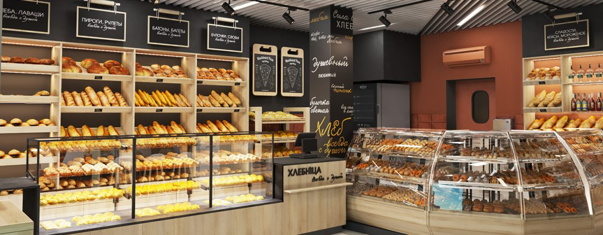

TABLE OF CONTENT
TABLE OF CONTENT 2
1.ORGANISATION OVERVIEW 3
CURRENT WEBSITE ANALYSIS 5
PROPOSED WEBSITES FEATURES AND FUNCTIONALITY 6
5.DESIGN AND USER EXPERIENCE 8
TECHNICAL REQUIREMENTS 10
TIMELINES AND MILESTONES 11
BUDGET 11
REFERENCES 12

1.ORGANISATION OVERVIEW

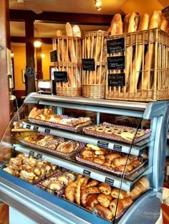
Brief History of the Bakery
- The bakery started in 2025 with a passion for baking.
- -It began as a small home baking idea.
- Friends and family encouraged the founder to turn it into a business.
- The bakery was created to sell fresh bread, cakes, and pastries.
- The goal is to provide fresh, affordable baked goods to the community
MISSION
- To provide fresh and high-quality baked goods every day.
- To make customers happy with delicious treats.
- To offer friendly service and affordable prices.
- To create a warm and welcoming bakery for the community
- The goal is to provide fresh, affordable baked goods to the community

VISION
- To become a popular and trusted bakery in the community.
- To provide fresh and delicious baked goods to all customers.
- To grow the bakery and offer more products in the future.
- To create a place where people enjoy quality baked treats.
- To build a strong reputation for quality and good service.

TARGET AUDIENCE
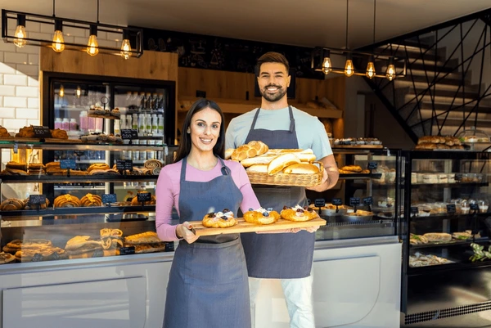
- Students who enjoy affordable snacks and baked treats.
- Families looking for fresh bread, cakes, and pastries.
- People in the local community love baked goods.
- Customers celebrate special occasions like birthdays and parties.
- Anyone who enjoys fresh and delicious bakery products.

2. WEBSITE GOALS AND OBJECTIVES
- To promote the bakery and its products online.
- To provide information about the bakery and what it offers.
- To attract new customers from the local community.
- To show the bakery’s menu and special baked goods.

KEY PERFORMANCE INDICATORS

WEBSITE TRAFFIC
I aim to reach 50 unique visitors within the first month of the website going live
USER ENQUIRIES
I want to receive at least 5 enquires per week through the online enquiry form
LOCATION CLICKS
I will measure success by tracking how many users click on the google Maps link to find our physical locations
SOCIAL MEDIA GROWTH
I aim to have 20% of my website traffic come from our social media pages

CURRENT WEBSITE ANALYSIS
STRENTHS
- The business has a strong local reputation for what they are good at
- They have a loyal customer base that supports the business regularly, and provides word to word marketing
- Unique offerings, the business offers specific items that are not easily found at larger competitors

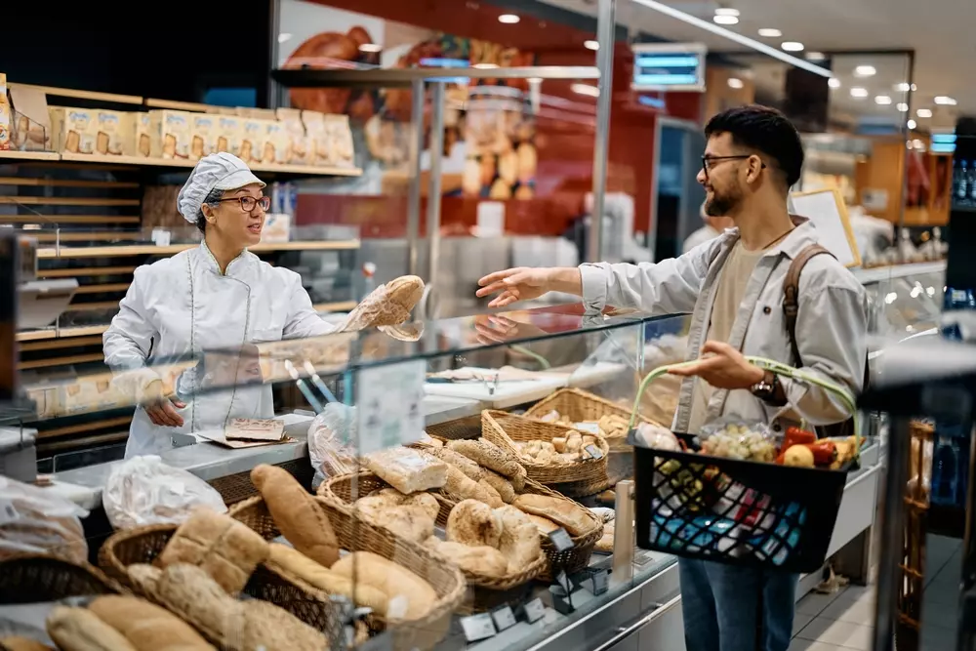

WEAKNESSES
- Currently, the business does not have a website, which limits their visibility to new customers.
- Information like menus and prices are not available online, making it hard for people to find details after hours

AREAS FOR IMPROVEMENT

DIGITAL TRANSFORMATION
- Building this website will provide a central place for all business information

AUTOMATED ENQUIRIES
- Adding a contact form will allow customers to reach out at any time, even after business hours

PROPOSED WEBSITES FEATURES AND FUNCTIONALITY
- Homepage Content
- What makes it special (fresh, homemade, quality ingredients)
- Welcome message
- Brief introduction of bakery
- Main products (bread, cakes, pastries

ABOUT US PAGE
- Brief history of the bakery
- Mission of the bakery
- Vision of the bakery
- What makes the bakery special (fresh, homemade, quality ingredients)
- Friendly and welcoming atmosphere
- Optional: team or founder introduction
SERVICES PAGE
- List of bakery products (bread, cakes, pastries, cookies)
- Special/custom orders (birthday cakes, wedding cakes)
- Seasonal or promotional items
- Short descriptions of each product
- Prices (optional)
- Attractive images of each product
- Highlight quality ingredients and freshness
CONTACT/ BOOKING PAGE
- Phone number
- Email address
- Physical location / address
- Opening hours
- Contact or inquiry form (optional)
- Social media links (Facebook, Instagram).

DESIRED FUNCTIONALITY
- Easy navigation between pages (Home, About Us, Services, Contact)
- Responsive design for computers, tablets, and phones
- Display attractive images of products
- Contact form for inquiries or orders
- Optional online ordering or booking system
- Integration with social media links
- Highlight special offers or promotions
- Search or menu filter (optional for products)

DESIRED FUNCTIONALITY
- Easy navigation between pages (Home, About Us, Services, Contact)
- Responsive design for computers, tablets, and phones
- Display attractive images of products
- Contact form for inquiries or orders
- Optional online ordering or booking system
- Integration with social media links
- Highlight special offers or promotions
- Search or menu filter (optional for products)

5.DESIGN AND USER EXPERIENCE

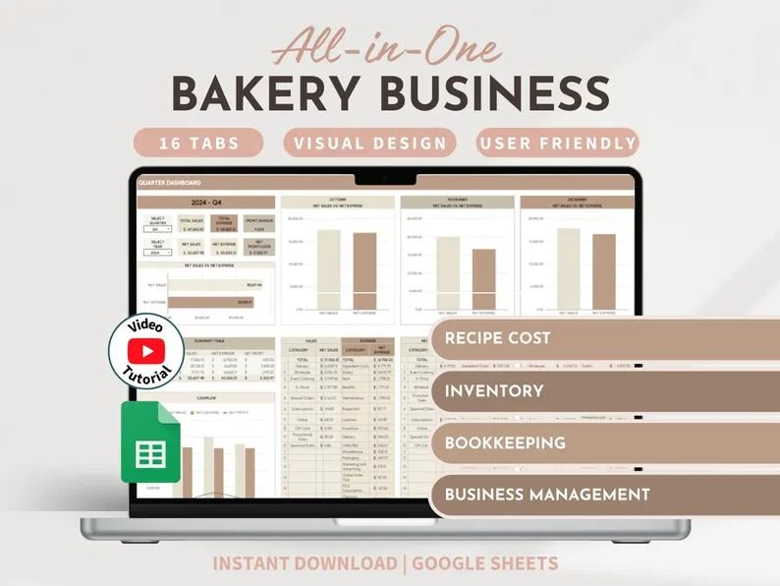

AESTHETIC AND BRANDING
Color Scheme
I’ve chosen a "Modern Organic" palette to give the bakery a warm and professional feel.
- Primary Background: I will use Beige and White to keep the site looking clean and fresh.
- Secondary Accents: Fawn and Dusty Pink will be used for sections and borders to add a soft, welcoming vibe.
- Call-to-Action (Buttons): I’ll use Olive Green for all buttons and important links because it stands out clearly against the lighter colors.
- Consistent font styles
- Typography: Black will be used for all texts to make sure everything is easy to read.
- Headings: I am using Playfair Display. It’s an elegant font that fits a high-end bakery style.
- Body Text: I’ll use Arial/Aptos. It is a clean font that is easy to read on mobile phones and laptops.
- Decorative fonts for headings
User Experience
Since I want the site to be easy to use, I am focusing on a simple layout. The most important information, like the menu and contact details, will be easy to find. I will also make sure the buttons are large enough to click on a touchscreen, and the images will be high-quality to make the products look appetizing.

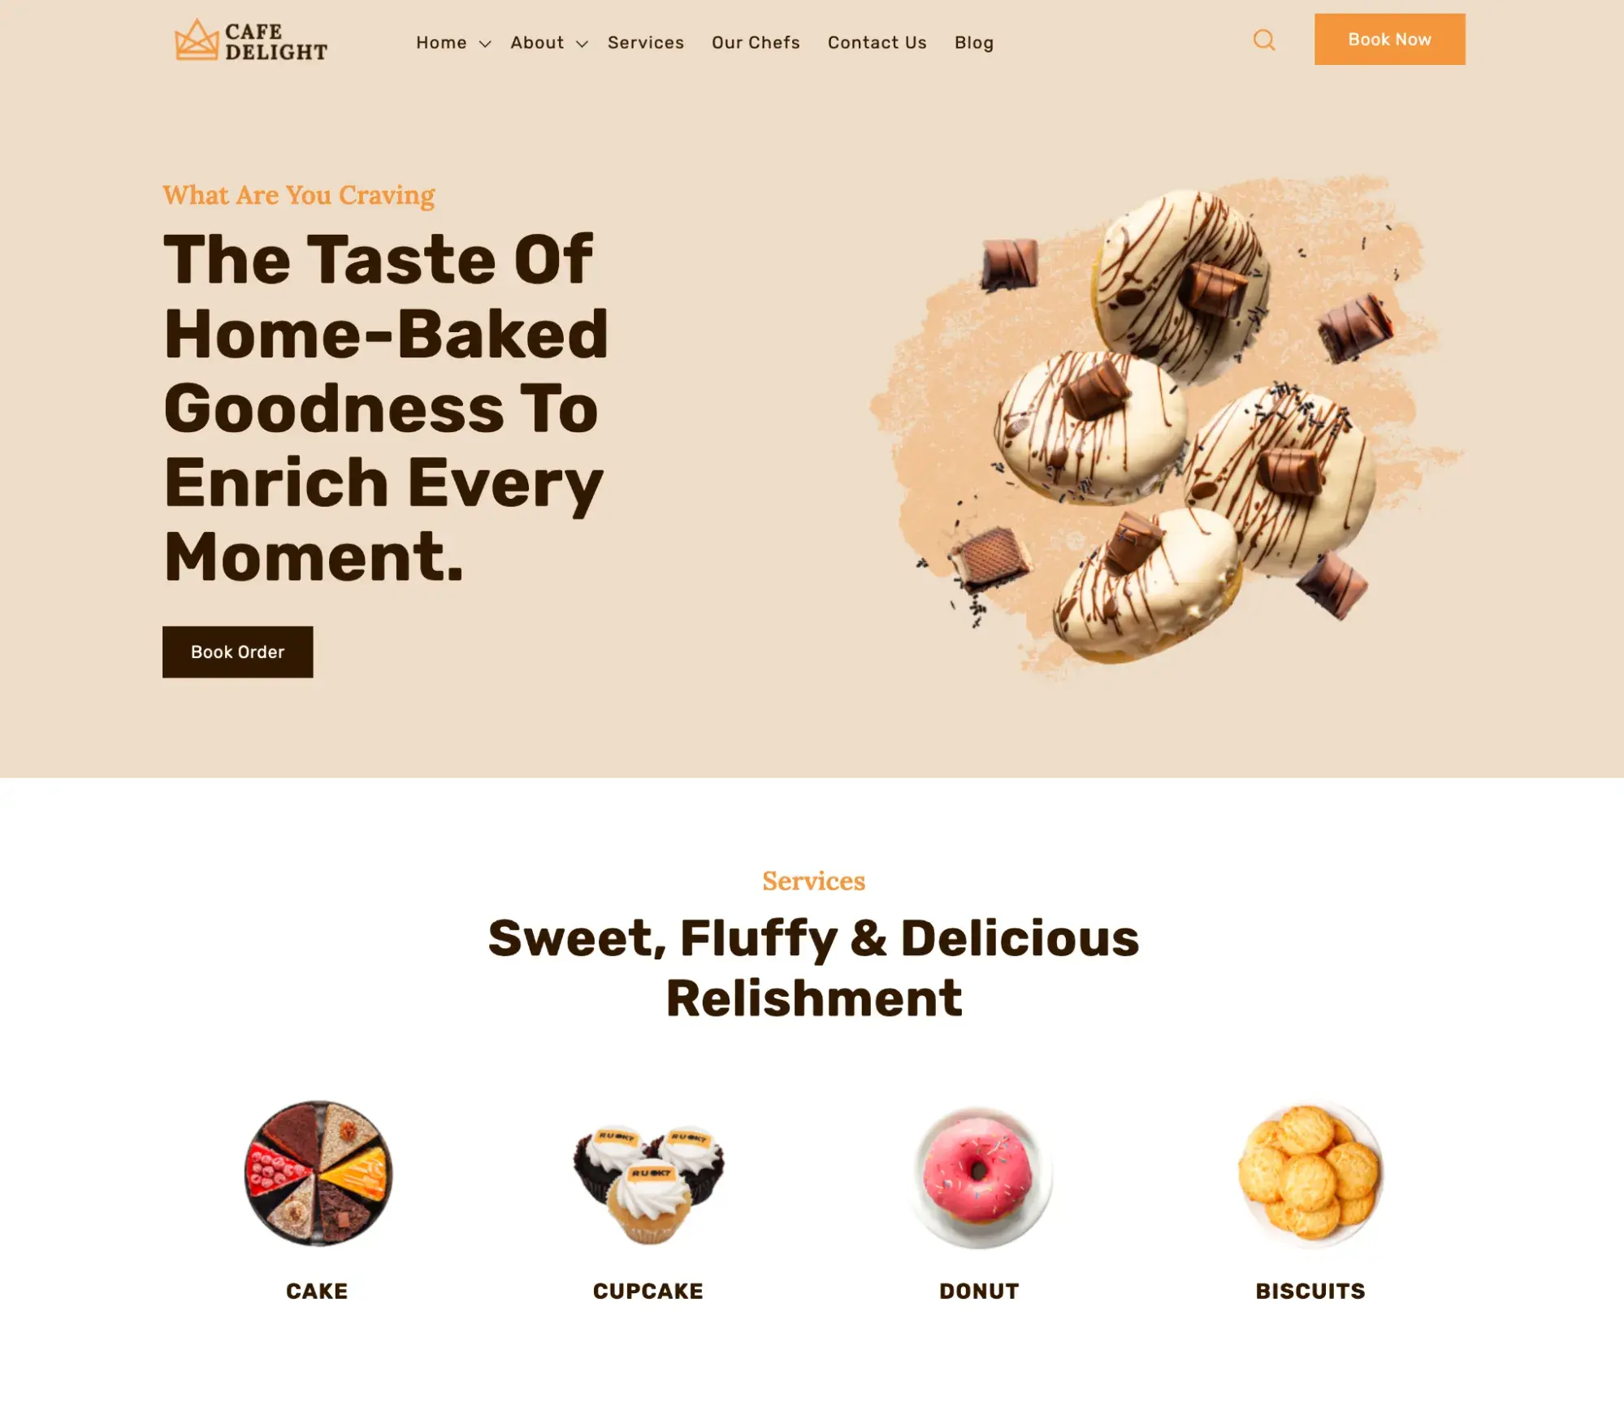
TECHNICAL REQUIREMENTS
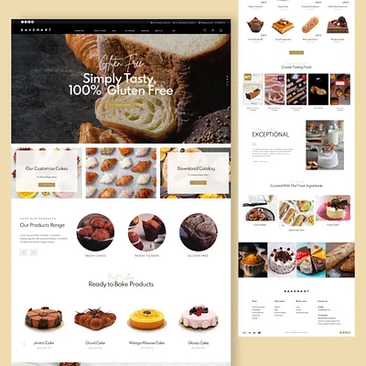

- Hosting and Domain Name
- A reliable web hosting service to make the website accessible online
- A custom domain name ( bakersdelight.www.co.za) for branding and easy access
- Programming Languages and Frameworks
- HTML for page structure
- CSS for styling and layout
- Optional JavaScript for interactivity (like image sliders or buttons)

TIMELINES AND MILESTONES
WEEK 1 TASK
Week1: Research and planning
Week2: Create website structure
Week3: Develop HTML pages

Week4: Testing and Debugging
Week 5: Final submission

BUDGET
ITEM | ESTIMATED COST
DORMAIN NAME | R200 PER YEAR
WEB MAINTENANCE | R500 PER YEAR
WEB HOSTING | R1200 PER YEAR

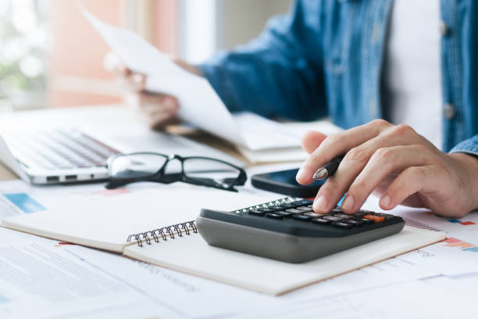

REFERENCES
Dribbble, 2026. Bakery landing page designs, themes, templates and downloadable graphic elements. [online] Available at: <https://dribbble.com/tags/bakery-landing-page > [Accessed 12 March 2026].
Google, 2026. Gemini. [online] Available at: <https://gemini.google.com/app/a4f7e7fd8c289436 >[Accessed 12 March 2026].
HubSpot, 2024. 21 Best Bakery Websites to Inspire Your Own Design. [online] Available at: <https://blog.hubspot.com/website/bakery-websites >[Accessed 12 March 2026].
iStock, 2026. Calculating finances stock photos, vectors, and illustrations. [online] Available at: <https://www.istockphoto.com/photos/calculating-finances >[Accessed 12 March 2026].
Limepack, 2024. Different types of bakeries – find your perfect match. [online] Available at:< https://www.limepack.eu/blog/bakery/different-types-of-bakeries-find-your-perfect-match/ >[Accessed 12 March 2026].
Pinterest, n.d. Bakery aesthetic. [online] Available at:< https://za.pinterest.com/bdrcookie/bakery-aesthetic/ >[Accessed 12 March 2026].
Pinterest, n.d. Bakery planner recipe cost calculator bakery spreadsheet inventory tracker bookkeeping order tracker home baker business business planner. [online] Available at: <https://in.pinterest.com/pin/bakery-planner-recipe-cost-calculator-bakery-spreadsheet-inventory-tracker-bookkeeping-order-tracker-home-baker-business-business-planner-etsy--3470587/ >[Accessed 12 March 2026].
Shutterstock, 2026. Bakery young people stock photos, vectors, and illustrations. [online] Available at: <https://www.shutterstock.com/search/bakery-young-people > [Accessed 12 March 2026].
Ukiosks, 2023. How to make a bakery shop interior design for french. [online] Available at: <https://ukiosks.com/how-to-make-a-bakery-shop-interior-design-for-french/ > [Accessed 12 March 2026].
W3Schools, 2026. W3Schools Online Web Tutorials. [online] Available at:< https://www.w3schools.com/ > [Accessed 12 March 2026].

